How to obtain the number of physical items held by institutions within the consortium by LC classification | 
Yoel Kortick
Senior Librarian

Question:
How can we make an Alma Analytics report of the number of physical items held by institutions within the consortium by LC classification?

Note:
This topic is relevant for a network zone institution.

ONE
In the network zone institution create a new report in the “titles” subject area.

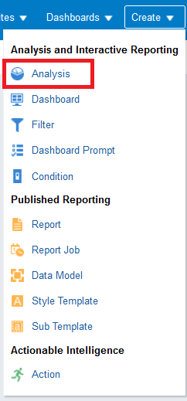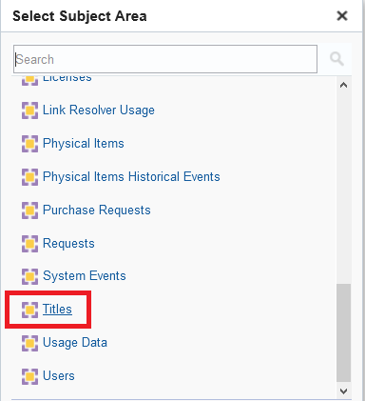

TWO
First we will make a report of each institution and how many items they have.
Later we will filter by and display the LC classifications.

In the “criteria” tab select the institution name, Institution Code, and the Number of active items:

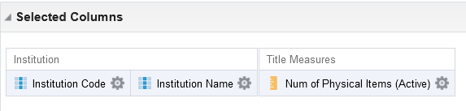

THREE
Check results

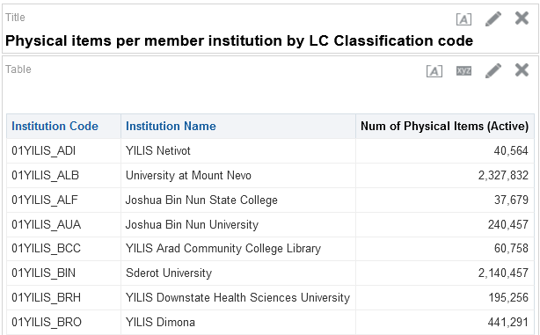

FOUR

Now we can add the desired field form the folder “LC Classifications” and add it for filtering and if desired also for display.
In the criteria tab we will add the “Group 1” from the “LC Classifications” folder.

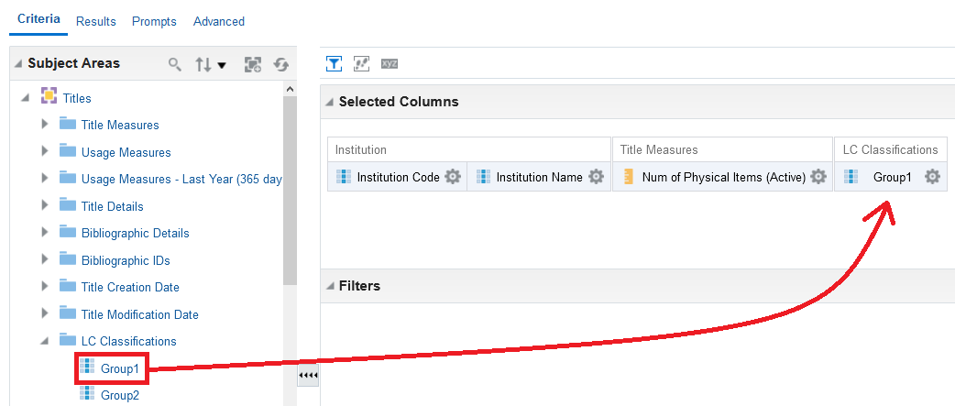

FIVE
Filter by whatever Group 1 you want. We will choose here “Libraries”

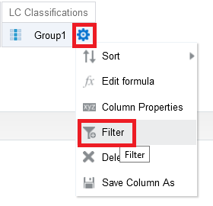

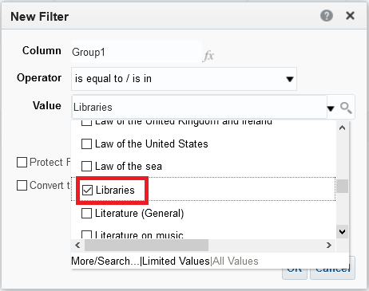

SIX
Check results

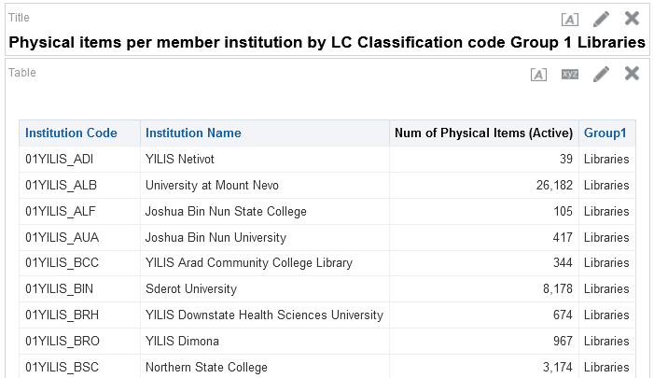

SEVEN
If desired we can now remove the “Group 1” from the display but leave it in the filter.
The name of the report states that it is for “Group 1 Libraries”

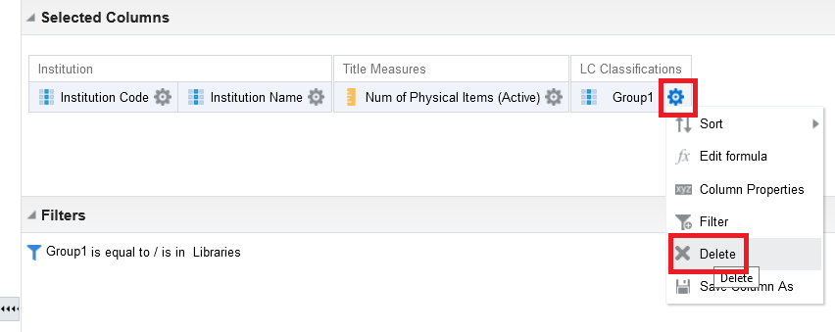

Now we have the filter but no display

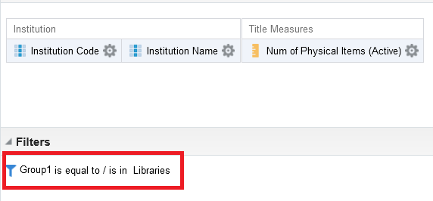

EIGHT

See final report

